Week 2 - Multi-Sensor Integration
Name: Swayam Rudrawar

Objective
The objective of this project is to interface multiple sensors with an ESP32 microcontroller and acquire real-time environmental and motion-related data. The project demonstrates sensor integration, I2C communication, digital sensor interfacing, and serial communication.

Components Used
1. ESP32 Development Board
2. DHT22 Temperature and Humidity Sensor
3. BMP180 Pressure Sensor
4. MPU6050 Accelerometer and Gyroscope Sensor
5. Breadboard
6. Jumper Wires

Pin Connections
DHT22 Connections
DHT22 Pin | ESP32 Pin
VCC | 3.3V
DATA | GPIO15
GND | GND
BMP180 Connections
BMP180 Pin | ESP32 Pin
VCC | 3.3V
SDA | GPIO21
SCL | GPIO22
GND | GND

MPU6050 Connections
MPU6050 Pin | ESP32 Pin
VCC | 3.3V
SDA | GPIO21
SCL | GPIO22
GND | GND

Circuit Diagram
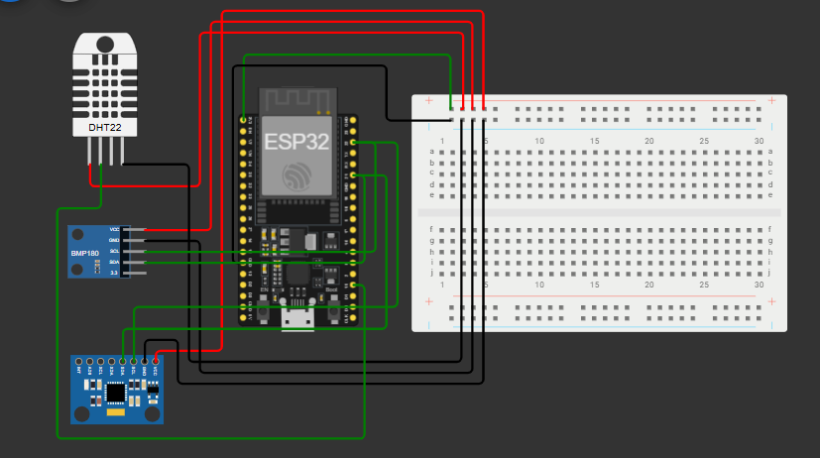

Program Code
#include <Wire.h>
#include <DHT.h>
#include <Adafruit_BMP085.h>
#include <Adafruit_MPU6050.h>
#include <Adafruit_Sensor.h>

#define DHTPIN 15
#define DHTTYPE DHT22

DHT dht(DHTPIN, DHTTYPE);

Adafruit_BMP085 bmp;
Adafruit_MPU6050 mpu;

void setup() {

Serial.begin(115200);

dht.begin();

if (!bmp.begin()) {
Serial.println("BMP180 not found");
while (1);
}

if (!mpu.begin()) {
Serial.println("MPU6050 not found");
while (1);
}

Serial.println("Smart Monitoring System Started");
}

void loop() {

float temperature = dht.readTemperature();
float humidity = dht.readHumidity();

float pressure = bmp.readPressure() / 100.0;
float altitude = bmp.readAltitude();

sensors_event_t a, g, temp;
mpu.getEvent(&a, &g, &temp);

Serial.println("--------------------------------");

Serial.print("Temperature: ");
Serial.print(temperature);
Serial.println(" C");

Serial.print("Humidity: ");
Serial.print(humidity);
Serial.println(" %");

Serial.print("Pressure: ");
Serial.print(pressure);
Serial.println(" hPa");

Serial.print("Altitude: ");
Serial.print(altitude);
Serial.println(" m");

Serial.print("Accel X: ");
Serial.println(a.acceleration.x);

Serial.print("Accel Y: ");
Serial.println(a.acceleration.y);

Serial.print("Accel Z: ");
Serial.println(a.acceleration.z);

Serial.print("Gyro X: ");
Serial.println(g.gyro.x);

Serial.print("Gyro Y: ");
Serial.println(g.gyro.y);

Serial.print("Gyro Z: ");
Serial.println(g.gyro.z);

delay(2000);
}

Output Screenshots

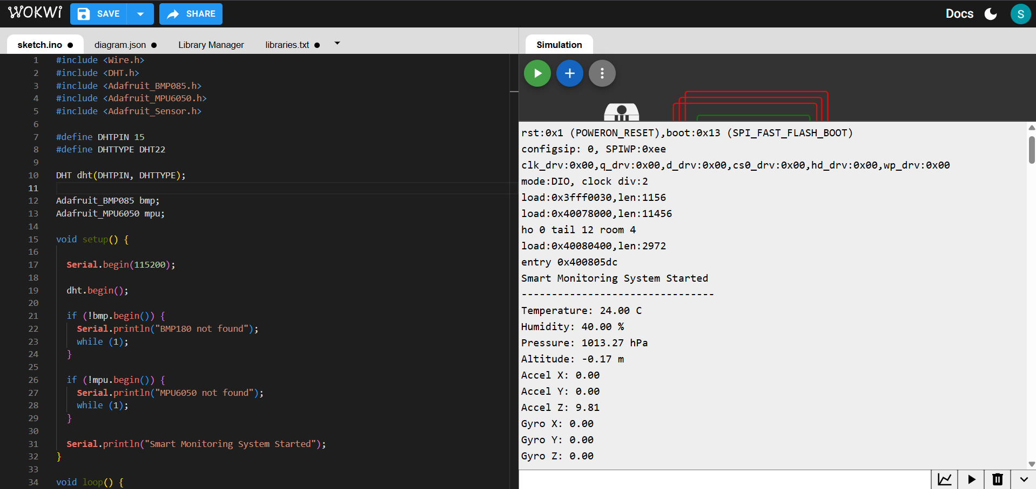

Communication Protocols Used
UART: Used to display sensor readings on the Serial Monitor.
I2C: Used for communication between ESP32, BMP180 and MPU6050 sensors.
Digital GPIO: Used for interfacing the DHT22 sensor.

Observations
• Temperature and humidity values changed according to DHT22 settings.
• Pressure and altitude values were successfully measured using BMP180.
• Acceleration and gyroscope readings changed according to MPU6050 movement simulation.
• I2C communication enabled multiple sensors to share the same SDA and SCL lines.
• Real-time monitoring was achieved through the ESP32 Serial Monitor.

Conclusion
The project successfully demonstrated the integration of DHT22, BMP180, and MPU6050 sensors with the ESP32 microcontroller. Environmental parameters and motion data were acquired and displayed in real time. The project provided practical experience in sensor interfacing, I2C communication, UART communication, and embedded system development.

